Perspectives in Psychology HAND REVIEW
Have students trace a copy of their open hand on a plain sheet of paper. Carefully review each digit and palm, assigning each a perspective. As applicable, have students mimic your actions to illustrate each. At the conclusion, you may wish to have students color their hands and create a visual to represent each perspective.
Thumb: Psychodynamic/Psychoanalytic
Point thumb directly behind the speaker (like you are hitchhiking). Explain that this refers to the past or past experiences. Explain that the psychodynamic psychologists focus on how past experiences, that have been repressed, impact our current experiences.
Pointer Finger: Cognitive
Point to your temple. Act as if you are thinking. Explain that this finger represents the cognitive perspective. Such psychologists are interested in all cognitive processes, such as decision-making.
Middle Finger: Behaviorism
Ask students how they know what “flipping someone off” means. Emphasize that this gesture is learned. Explain that we learn by watching others (modeling), through punishment or reinforcement, and by pairing events closely in time. Also, this is an overt behavior that can be measured.
Ring Finger: Humanism
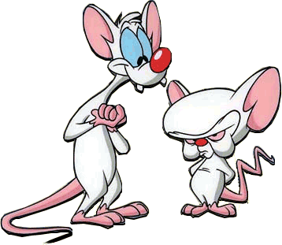
Have students attempt to lift their ring finger straight up. This is difficult. Use the fingers on your other hand, to “help” this finger come to “standing”…its full potential. Explain that humanists believe that we can all reach our fullest potential. We often need help from others (unconditional positive regard) to develop a positive self-concept.
Pinky: Biology
Say, “Pinky and the…” Students should fill it in with “brain” based on the cartoon “Pinky and the Brain.” Explain that the pinky is small and so is our knowledge concerning all functions of the brain and genetics in our behavior.
Palm: Socio-Cultural
Outstretch both arms and bring your palms towards yourself in a hug. Explain that we are embracing our differences. To understand others we must understand their cultural backgrounds.

